<!DOCTYPE html>

<html>

<head>

<title>W3.CSS Template</title>

<meta charset="UTF-8">

<meta name="viewport" content="width=device-width, initial-scale=1">

<link rel="stylesheet" href="https://www.w3schools.com/w3css/4/w3.css">

<link rel="stylesheet" href="https://fonts.googleapis.com/css?family=Amatic+SC">

<style>

body, html {height: 100%}

body,h1,h2,h3,h4,h5,h6 {font-family: "lato", sans-serif}

.menu {display: none}

.bgimg {

background-repeat: no-repeat;

background-size: cover;

background-image: url("/w3images/pizza.jpg");

min-height: 90%;

}

</style>

</head>

<body>

<!-- Links (sit on top) -->

<div class="w3-top">

<div class="w3-row w3-large w3-light-grey">

<div class="w3-col s3">

<a href="#" class="w3-button w3-block w3-black">HOME</a>

</div>

<div class="w3-col s3">

<a href="#register" class="w3-button w3-block w3-black">REGISTER</a>

</div>

<div class="w3-col s3">

<a href="#about" class="w3-button w3-block w3-black">ABOUT US</a>

</div>

<div class="w3-col s3">

<a href="#contact" class="w3-button w3-block w3-black">CONTACT</a>

</div>

</div>

</div>

<!-- Content -->

<table>

<tr>

<td>

<div class="w3-col m6">

<img class="w3-image w3-round-large" src="C:\Users\sharm\OneDrive\Pictures\a1.jfif" alt="Buildings" width="500" height="600" float="left">

</div>

</td>

<td>

<div class="w3-container w3-light-grey" style="padding:128px 16px">

<div class="w3-row-padding">

<div class="w3-col

<div class="w3-panel">

<h1><center><b>KAMARAJ</b></center></h1>

<h2><center><b>COLLEGE OF ENGINEERING AND TECHNOLOGY</b></center></h2>

<h3><center>(Autonomous)</center></h3>

<h4><center>S.P.G Chidambara Nadar-C.Nagammal Campus,<br>

S.P.G.C Nagar,K.Vellakulam-625 701 (Near VIRUDHUNAGAR).</center></h4>

</div>

</div>

</div>

<td>

<img class="w3-image w3-round-large" src=<td>

<img class="w3-image w3-round-large" src="C:\Users\sharm\OneDrive\Pictures\n2.png" width="300" height="300" float="left">

</td> alt="Buildings" width="200" height="300" float="left">

</td>

<td>

<img class="w3-image w3-round-large" src="C:\Users\sharm\OneDrive\Pictures\Screenshots\n1.png" alt="Buildings" width="300" height="300" float="left">

</td>

</td>

</tr>

</table>

<style>

body {

font-family: Arial, Helvetica, sans-serif;

}

* {

box-sizing: border-box;

}

input[type=text], select, textarea {

width: 100%;

padding: 12px;

border: 1px solid #ccc;

margin-top: 6px;

margin-bottom: 16px;

resize: vertical;

}

input[type=submit] {

background-color: #04AA6D;

color: white;

padding: 12px 20px;

border: none;

cursor: pointer;

}

input[type=submit]:hover {

background-color: #45a049;

}

.container {

border-radius: 5px;

background-color: #f2f2f2;

padding: 10px;

}

.column {

float: left;

width: 50%;

margin-top: 6px;

padding: 30px;

}

.row:after {

content: "";

display: table;

clear: both;

}

@media screen and (max-width: 600px) {

.column, input[type=submit] {

width: 100%;

margin-top: 0;

}

}

</style>

</head>

<body>

<!DOCTYPE html>

<html>

<head>

<meta name="viewport" content="width=device-width, initial-scale=1">

<style>

/* Slideshow container */

.slideshow-container {

max-width: 1000px;

position: relative;

margin: auto;

}

/* Next & previous buttons */

.prev, .next {

cursor: pointer;

position: absolute;

top: 50%;

width: auto;

padding: 16px;

margin-top: -22px;

color: white;

font-weight: bold;

font-size: 18px;

transition: 0.6s ease;

border-radius: 0 3px 3px 0;

user-select: none;

}

/* Position the "next button" to the right */

.next {

right: 0;

border-radius: 3px 0 0 3px;

}

/* On hover, add a black background color with a little bit see-through */

.prev:hover, .next:hover {

background-color: rgba(0,0,0,0.8);

}

/* Caption text */

.text {

color: #f2f2f2;

font-size: 15px;

padding: 8px 12px;

position: absolute;

bottom: 8px;

width: 100%;

text-align: center;

}

/* Number text (1/3 etc) */

.numbertext {

color: #f2f2f2;

font-size: 12px;

padding: 8px 12px;

position: absolute;

top: 0;

}

/* The dots/bullets/indicators */

.dot {

cursor: pointer;

height: 15px;

width: 15px;

margin: 0 2px;

background-color: #bbb;

border-radius: 50%;

display: inline-block;

transition: background-color 0.6s ease;

}

.active, .dot:hover {

background-color: #717171;

}

/* Fading animation */

.fade {

animation-name: fade;

animation-duration: 1.5s;

}

@keyframes fade {

from {opacity: .4}

to {opacity: 1}

}

/* On smaller screens, decrease text size */

@media only screen and (max-width: 300px) {

.prev, .next,.text {font-size: 11px}

}

.box {

background-color: darkblue;

width: 900px;

border: 15px solid white;

padding: 50px;

margin: 10px;

border-radius: 100px;

}

</style>

</head>

<body>

<div class="w3-container w3-light-grey" style="padding:128px 16px">

<div class="w3-row-padding">

<div class="w3-col

<div class="w3-panel">

<marquee width="100%" direction="left" height="100px">

<h1><hr>DEPARTMENT OF INFORMATION TECHNOLOGY</h1></hr>

</marquee>

<div class="slideshow-container">

<div class="mySlides fade">

<div class="numbertext">1 / 3</div>

<img src="pic5.jpeg" style="width:100%">

<div class="text">Entrance</div>

</div>

<div class="mySlides fade">

<div class="numbertext">2 / 3</div>

<img src="pic1.jpeg" style="width:100%">

<div class="text">Day</div>

</div>

<div class="mySlides fade">

<div class="numbertext">3 / 3</div>

<img src="pic2.jpeg" style="width:100%">

<div class="text"><Hdr></Hdr>Happy</div>

</div>

<a class="prev" onclick="plusSlides(-1)">❮</a>

<a class="next" onclick="plusSlides(1)">❯</a>

</div>

<br>

<div style="text-align:center">

<span class="dot" onclick="currentSlide(1)"></span>

<span class="dot" onclick="currentSlide(2)"></span>

<span class="dot" onclick="currentSlide(3)"></span>

</div>

</div>

</div>

</div>

<script>

let slideIndex = 1;

showSlides(slideIndex);

function plusSlides(n) {

showSlides(slideIndex += n);

}

function currentSlide(n) {

showSlides(slideIndex = n);

}

function showSlides(n) {

let i;

let slides = document.getElementsByClassName("mySlides");

let dots = document.getElementsByClassName("dot");

if (n > slides.length) {slideIndex = 1}

if (n < 1) {slideIndex = slides.length}

for (i = 0; i < slides.length; i++) {

slides[i].style.display = "none";

}

for (i = 0; i < dots.length; i++) {

dots[i].className = dots[i].className.replace(" active", "");

}

slides[slideIndex-1].style.display = "block";

dots[slideIndex-1].className += " active";

}

</script>

<center>

<video width="1000" height="250" controls>

<source src="video.mp4" type="video/mp4">

</video>

</center>

</body>

<div class="container" id="register">

<div style="text-align:center">

<h2>NEW REGISTRATION</h2>

<p><b>Students fill their details properly:</b></p>

</div>

<table align="center">

<tr>

<td width="100"><img src="https://encrypted-tbn0.gstatic.com/images?q=tbn:ANd9GcRX3yVeSLaE2OplVJ9D5ryWGqiIA9M9wddUNg&usqp=CAU"></td>

</tr>

<div class="column">

<form action="/action_page.php">

<label for="fname">First Name</label>

<input type="text" id="fname" name="firstname" placeholder="Your name..">

<label for="lname">Last Name</label>

<input type="text" id="fname" name="firstname" placeholder="Your last name..">

<label for="dob">Date of Birth</label>

<input type="text" id="dob" name="dob" placeholder="Your dob..">

<label for="mark1">SSLC MARK</label>

<input type="text" id="mark1" name="mark1" placeholder="Your 10th mark">

<label for="mark2">HSC MARK</label>

<input type="text" id="mark2" name="mark2" placeholder="Your 12th mark">

<label for="jyear">Year of Joining</label>

<input type="text" id="jyear" name="jyear" placeholder="joining year...">

<label for="country">department</label>

<select id="country" name="country">

<option value="select">---Select any one dept---</option>s

<option value="it">INFORMATION TECHNOLOGY</option>

<option value="csc">COMPUTER SCIENCE</option>

<option value="civil">CIVIL</option>

</select>

<label for="subject">Year of Studying</label>

<input type="text" id="yname" name="yname" placeholder="Year...">

<br>

<input type="submit" value="Submit">

</form>

</div>

</div>

</div>

<style>

<!DOCTYPE html>

<html>

<link href="https://cdn.jsdelivr.net/npm/bootstrap@5.3.0/dist/css/bootstrap.min.css" rel="stylesheet" integrity="sha384-9ndCyUaIbzAi2FUVXJi0CjmCapSmO7SnpJef0486qhLnuZ2cdeRhO02iuK6FUUVM" crossorigin="anonymous">

<head>

<style>

div.gallery {

margin: 5px;

border: 1px solid #ccc;

float: left;

width: 180px;

border-radius: 10px;

}

div.gallery:hover {

border: 1px solid black;

}

div.gallery img {

width: 100%;

}

div.desc {

padding: 15px;

text-align: center;

font-size: 12px;

}

</style>

</head>

<body>

<script src="https://cdn.jsdelivr.net/npm/bootstrap@5.3.0/dist/js/bootstrap.bundle.min.js" integrity="sha384-geWF76RCwLtnZ8qwWowPQNguL3RmwHVBC9FhGdlKrxdiJJigb/j/68SIy3Te4Bkz" crossorigin="anonymous"></script>

<center>

<table>

<tr>

<td>

<div class="gallery">

<a target="#" href="index.html">

<img src="vakai.png" alt="Cinque Terre" width="600" height="200">

</a>

<div class="desc"><b style="color:darkgoldenrod"><b> Dr.E.Vaikaimala,Ph.Dr</b></b></div>

</div>

</td>

<td>

<div class="gallery">

<a target="#" href="index.html">

<img src="kaviya.png" alt="Forest" width="600" height="200">

</a>

<div class="desc"><b style="color:darkgoldenrod"><b>MS.P.kaviya,M.Tech</b></b></div>

</div>\

</td>

<td>

<div class="gallery">

<a target="#" href="index.html">

<img src="C:\Users\sharm\Downloads\arthy.png" alt="Northern Lights" width="600" height="200">

</a>

<div class="desc"><b style="color:darkgoldenro"><b>Dr.R.Arthy,Ph.D<br></b></b></div>

</div>

</td>

<td>

<div class="gallery">

<a target="#" href="index.html">

<img src="C:\Users\sharm\Downloads\agila.png" alt="Mountains" width="600" height="200">

</a>

<div class="desc"><b style="color:darkgoldenrod"><b>Dr.R.Aghila,Ph.D<br></b></b></div>

</div>

</td>

</tr>

<tr>

<td>

<div class="gallery">

<a target="#" href="index.html">

<img src="C:\Users\sharm\Downloads\deepa.png" alt="Mountains" width="600" height="200">

</a>

<div class="desc"><b style="color:darkgoldenrod"><b>MRS.V.Deepa priya,M.E(Ph.D)</b></b></div>

</div>

</td>

<td>

<div class="gallery">

<a target="#" href="index.html">

<img src="vendahn.png" alt="Mountains" width="600" height="200">

</a>

<div class="desc"><b style="color:darkgoldenrod"><b>MRS.D.Vendhan,M.Tech.(Ph.D)</b></b></div>

</div>

</td>

<td>

<div class="gallery">

<a target="#" href="index.html">

<img src="raj.png" alt="Mountains" width="600" height="200">

</a>

<div class="desc"><b style="color:darkgoldenrod"><b>MRS.C.Rajakannan,M.E</b></b></div>

</div>

</td>

<td>

<div class="gallery">

<a target="#" href="index.html">

<img src="C:\Users\sharm\Downloads\ram.png" alt="Mountains" width="600" height="200">

</a>

<div class="desc"><b style="color:darkgoldenrod"><b>Mr.Ram Ganeshan.G.H.M.E,</b></b></div>

</div>

</td>

</tr>

<tr>

<td>

<div class="gallery">

<a target="#" href="index.html">

<img src="C:\Users\sharm\Downloads\maha.png" alt="Mountains" width="600" height="200">

</a>

<div class="desc"><b style="color:darkgoldenrod"><b>MRS.P.Mahalakshmi,M.E</b></b></div>

</div>

</td>

<td>

<div class="gallery">

<a target="#" href="index.html">

<img src="priya.png" alt="Mountains" width="600" height="200">

</a>

<div class="desc"><b style="color:darkgoldenrod"><b>MRS.P.Priyadharshini,M.E</b></b></div>

</div>

</td>

<td>

<div class="gallery">

<a target="#" href="index.html">

<img src="gaya.png" alt="Mountains" width="600" height="200">

</a>

<div class="desc"><b style="color:darkgoldenrod"><b>MRS.S.Gayathiri,M.E</b></b></div>

</div>

</td>

<td>

<div class="gallery">

<a target="#" href="index.html">

<img src="arun.png" alt="Mountains" width="600" height="200">

</a>

<div class="desc"><b style="color:darkgoldenrod"><b>MR.S.Arun Prasad,M.Tech</b></b></div>

</div>

</td>

</tr>

<tr>

<td>

<div class="gallery">

<a target="#" href="index.html">

<img src="kaya.png"alt="Mountains" width="600" height="200">

</a>

<div class="desc"><b style="color:darkgoldenrod"><b>MRS.v.Gayathiri,M.E</b></b></div>

</td>

</tr>

</table>

</div>

</center>

</body>

</html>

<div class="w3-row-padding" id="about">

<div class="w3-center w3-padding-64">

<span class="w3-xlarge w3-bottombar w3-border-dark-grey w3-padding-16">DEPARTMENT ACHIVEMENTS</span>

</div>

<p><center>Welcome to the IT Department at Kamaraj College of Engineering and Technology Our department is at the forefront of the ever-evolving field of Information Technology,

empowering individuals and organizations to thrive in the digital age. With a legacy dating back to our establishment in 2001, we have been consistently delivering

exceptional education and producing high-calibre technocrats. Our team consists of twelve vibrant and highly qualified faculty members who possess expertise in various

domains of Information Technology. Among them, three faculty members have successfully completed their doctoral degrees and four faculty members are actively pursuing their doctorates.

This ensures that our students receive the most up-to-date and relevant knowledge in the field. At our department, we have a clear objective to equip our students with the

skills and knowledge needed to tackle the challenges of the rapidly changing world. We pride ourselves on provid

ing comprehensive education that prepares our students to excel in the IT industry. With Information Technology being an integral part of almost every profession,

we emphasize a multidisciplinary approach that encompasses a wide range of key areas. Our curriculum covers Artificial Intelligence, Augmented Reality, Data Analytics, Networking,

Data Management, Cyber security, Communications, Web Technology, Software Design, and Systems Management and Administration.

</center></p>

<div class="w3-row-padding" id="about">

<div class="w3-center w3-padding-64">

<span class="w3-xlarge w3-bottombar w3-border-dark-grey w3-padding-16">STUDENTS ACHIVEMENTS</span>

</div>

<p> DhanasekaraPandian.G of III IT secured Second Prize for the event “MEME Creation” at MISRIMAL NAVAJEE MUNOTH JAIN Engineering College on 01.06.2022

Pandiraja P, Santhosh G, Venkatesh Prabhu R of III IT won second prize on “ Top Coders’22” at Sutharson Engineering College, Coimbatore on 22.04.2022

Karthikeyan R of III IT won Third Prize on the photography event of Infosparks 2K22 at Kalasalingam Academy of Research and Education on 29.04.2022

Gokula Indira R of III IT secured First place in Intercollege Dance Competition at Kalasalingam University on the month of April 2022.

Ananthan C.P of III IT secured First place in Intercollege Dance Competition at Kalasalingam University on the month of April 2022

Ananthan C.P of III IT won First prize on Infosparks 2K22- Instagram Content Creation at Kalasalingam Academy of Research and Education on 29.04.2022

Pandiraja P, Venkatesh Prabhu R, DhanasekaraPandian G. Abhishek, Santhosh G of III IT secured First place on Build –A_Thon (Intracollege Project Competetion) at Kamaraj College of Engineering & Technology on 27.05.2022.

Nagarjun G, Uma Maheshawari A, Priyanka M of III IT undergone one month CISCO virtual internship

Sundareswaran J, Karthikeyan M, Manikumar T, Fedrin Rodriguez S, Sreenath Vaisakh N of II IT secured Second place on Build –A_Thon (Intracollege Project Competetion) at Kamaraj College of Engineering & Technology on 27.05.2022.

Manikumar T of II IT won Second prize in CIPHERFEST Event “Error Seek” at Kamaraj College of Engineering & Technology on 20.11.2021.

Harshitha B of II IT completed the course on ChatBot or Smart Assistant Development as a part of Cisco Thing Qbator program.

Harivignesh M, Abul Faizal M, Sivapriyan A of IV IT won first prize on “TechnoVision 2K22”, an intra-college project competition on 13.04.2022

K.ArasaMuniViyasar, M.Karthikeyan, A.JeyaRubesh secured the best project award on “TechnoVision 2K22”, an intra-college project competition on 13.04.2022

Abinaya. M,Nandhini. S,Chanjaiy. J,Gopinath.R of IV IT presented a paper titled “Muzik Emoticon Based Music Recommendation System” on International Conference on recent trends in Engineering Technology and Management at Christ the King Engineering College, Coimbatore on 06.05.2022

Pravenna.G, Karishma. V, Shreenithy.R of IV IT presented a paper titled “An Ensemble Learning Approach for Intrusion Detection System Using Machine Learning Techniques” on International Conference on recent trends in Engineering Technology and Management at Christ the King Engineering College, Coimbatore on 06.05.2022

Anu Priya. S, Banu Priya. S, Pappasri. D of IV IT presented a paper titled “Secured Image Sharing without Pixel Expansion using Visual Cryptography” on International Conference on recent trends in Engineering Technology and Management at Christ the King Engineering College, Coimbatore on 06.05.2022

Jeya Rubesh. A, Arasa Muni Viyasar. K, Karthikeyan. M of IV IT presented a paper titled “Intelligence Based Remote Health Monitoring” on International Conference on Software Engineering and Information Technology, Ernakulam on 05.05.2022

Kavinila. M, Harithanjali. K, Mridini. M of IV IT presented a paper titled “Door Automation System” on National Conference on “Emerging Trends in Information and Communication Engineering (NCETICE’22)” at Care College of Engineering, Trichy on 06.05.2022

Hindhuja. R, Swetha.S of IV IT presented a paper titled “Automatic Dog Feeder System Using IoT” on Emerging Trends in Information and Communication Engineering (NCETICE’22)” at Care College of Engineering, Trichy on 06.05.2022

Mahendran. A, Ragul. T, Meenakshi Sundaram. G of IV IT presented a paper titled “College Chat Bot” on Emerging Trends in Information and Communication Engineering (NCETICE’22)” at Care College of Engineering, Trichy on 06.05.2022

Karthika. G, Kayal Arasi. R, Manikandan. M, Saravana Santhosh. M of IV IT presented a paper titled “Digital Signature Verification Using Deep Learning Technique” on Emerging Trends in Information and Communication Engineering (NCETICE’22)” at Care College of Engineering, Trichy on 06.05.2022.

Dharika M, Lavanya S, Shyamala M of III IT completed Nation Level E-Quiz on “Mathematics and its Apllications” with 85% score on 21.05.2021

</p>

<style>

.box {

width: 900px;

height: 700px;

border: 15px solid skyblue;

padding: 50px;

margin: 10px;

}

.img {

max-width: 15%;

max-height:25%;

float: left;

}

</style>

<body>

<center>

<div class="box">

<h1 style="color:black;" align="center">EXTRA CRICULAR </h1>

<table align="center">

<tr>

<td width="100"><img src="sub.png"></td>

<td width="100"> <img src="arthi.png"></td>

<td width="100"> <img src="sharmi1.png"></td>

width: 800px;

height: 500px; </tr>

</table>

<h3 style="color:pink;" >The Students Who had participated and won Third Prize in Anna University Volley Ball Tournament<br>,which is held in Bharath Niketan Engineering And Polytechnic College,Theni</h3>

<br>

<table align="center">

</table>

</div>

</center>

<style>

.box1 {

border: 15px lightblue;

padding: 50px;

margin: 10px;

}

.img {

max-width: 40%;

max-height:30%;

float: left;

}

</style>

<body>

<div class="box1">

<h1 style="color:red;" align="center">NON-TECHNICAL EVENT</h1>

<table align="center">

<tr>

<td width="100"><img src="C:\Users\sharm\Downloads\meena.jpeg" width="300" height="250"></td>

<h3 style="color:black;" >Meenakshi is participated and won first Prize in 5 minutes,which is held in Karpagam College of Engineering And technology,coimbatore</h3>

</table>

</body>

<!-- Contact -->

<div class="w3-center w3-padding-64" id="contact">

<span class="w3-xlarge w3-bottombar w3-border-dark-grey w3-padding-16">Contact Us</span>

</div>

<form class="w3-container" action="/action_page.php" target="_blank">

<div class="w3-section">

<label>Name</label>

<input class="w3-input w3-border w3-hover-border-black" style="width:100%;" type="text" name="Name" required>

</div>

<div class="w3-section">

<label>Email</label>

<input class="w3-input w3-border w3-hover-border-black" style="width:100%;" type="text" name="Email" required>

</div>

<div class="w3-section">

<label>Subject</label>

<input class="w3-input w3-border w3-hover-border-black" style="width:100%;" name="Subject" required>

</div>

<div class="w3-section">

<label>Message</label>

<input class="w3-input w3-border w3-hover-border-black" style="width:100%;" name="Message" required>

</div>

<button type="submit" class="w3-button w3-block w3-black">Send</button>

</form>

</div>

<!-- Footer -->

<footer class="w3-container w3-padding-32 w3-light-grey w3-center">

<h4>Footer</h4>

<a href="#" class="w3-button w3-black w3-margin"><i class="fa fa-arrow-up w3-margin-right"></i>To the top</a>

<div class="w3-xlarge w3-section">

<!-- Footer -->

<div class="w3-xlarge w3-section">

<table width="50%">

<tr>

<td><img src="C:\Users\sharm\OneDrive\Pictures\a1.jfif"></td>

<td><center>KAMARAJ COLLEGE OF ENGINEERING & TECHNOLOGY</center><br>

<center>S.P.G.Chidambara nadar - C.Nagammal Campus</center><br>

<center> S.P.G.C. Nagar, K.Vellakulam-625 701, Near Virudhunagar</center></td><br><br><td><br></td>

</tr>

</table>

<td><img src= "C:\Users\sharm\OneDrive\Pictures\proj1.JPG" width="100%" height="100%" ></td>

<a href="#" class="fa fa-facebook"></a>

<a href="#" class="fa fa-twitter"></a>

<a href="http://www.kamarajengg.edu.in/" class="fa fa-google"></a>

<a href="https://www.linkedin.com/school/kamarajeng/" class="fa fa-linkedin"></a>

<a href="https://youtube.com/@kvedha.vk7538" class="fa fa-youtube"></a>

<a href="https://instagram.com/kamarajeng?igshid=MzRlODBiNWFlZA==" class="fa fa-instagram"></a>

<link rel="stylesheet" href="https://cdnjs.cloudflare.com/ajax/libs/font-awesome/4.7.0/css/font-awesome.min.css">

</body>

</head>

</html>

<p>Powered by <a href="http://www.kamarajengg.edu.in/" title="---sharmii---" target="_blank" class="w3-hover-text-green">--sharmi---</a></p>

</footer>

<script>

function showDivs(n) {

var i;

var x = document.getElementsByClassName("mySlides");

var dots = document.getElementsByClassName("demodots");

if (n > x.length) {slideIndex = 1}

if (n < 1) {slideIndex = x.length} ;

for (i = 0; i < x.length; i++) {

x[i].style.display = "none";

}

for (i = 0; i < dots.length; i++) {

dots[i].className = dots[i].className.replace(" w3-white", "");

}

x[slideIndex-1].style.display = "block";

dots[slideIndex-1].className += " w3-white";

}

</script>

</body>

</html>

**Output:**





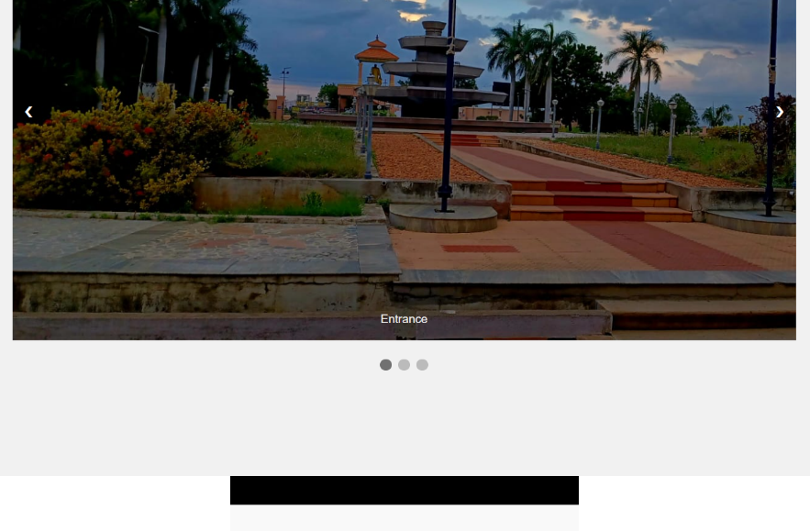



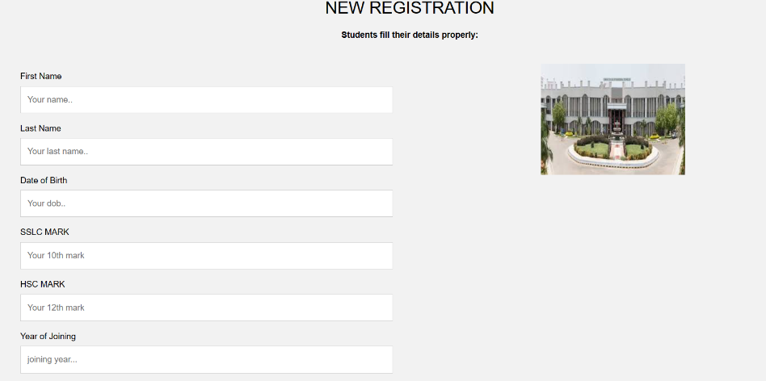

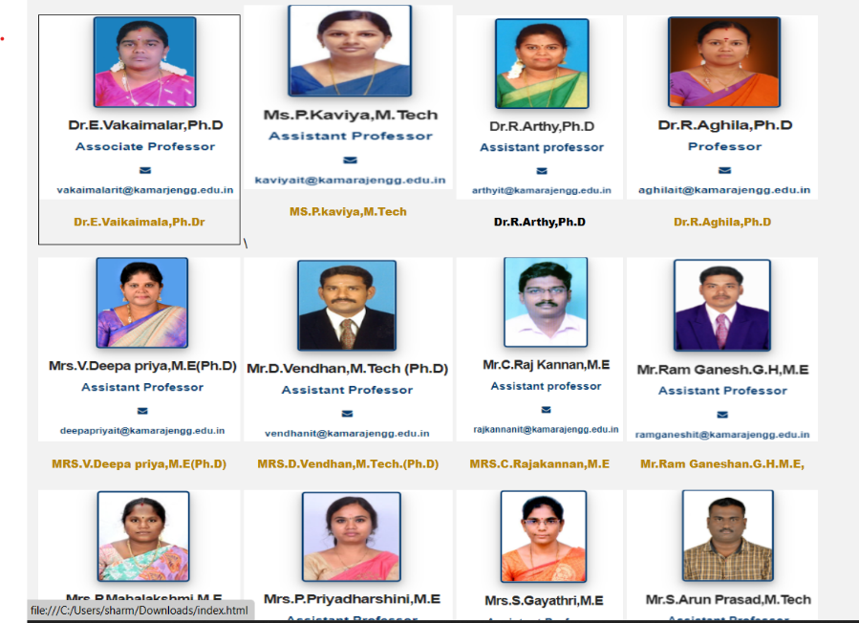

s

